GEORGIA STATE UNIVERSITY

Department of Computer Science

CSC 3210 Computer Organization Programming

Lab Section:

Lab 1: Synchronized Traffic Light Design

Linh H. Pham

**Contents**

**1 Introduction**

**2 Apparatus**

**3 Methods**

**4 Results and Discussion**

**5 Conclusions**

1. **Introduction**

This lab asks for designing a finite state machine to control traffic lights near Georgia State University’s T-deck. The goal is to try to direct the traffic in the area, based on direction and rate, in order to efficiently allow student cars to access the deck without congesting the flow of traffic.

**2 Apparatus**

* drawio.com
* Excel

**3 Methods**

Identify the relation between the lights to be able to set them up correctly in different states. For East-West lights to be green, lights of North-West roads must be red, and vice versa. Draw a Finite State Machine base of the infos.

The duration of the lights will be based on the length of the street and the rate of cars. For example, the Auburn Ave section between lights (C) and (D) is about 400 ft long, so it can contain a maximum of 400/20 == 20 cars. Let says 10 cars is the maximum cars that must wait, with a rate of 2 – 5 seconds per car coming from Courtland Street and Peachtree Center Ave, the red lights can wait for at least 30s.

Based on the FSM, create a state transition table and Karnaugh maps, with 2-bits input/output.

From the K-maps, create logic functions that represent logic circuits.

**4 Results and Discussion**

Identify the streets and their directions to determine the states for each street. For example, for cars on Peachtree Center Ave or Courtland Street to move, Auburn Ave traffic must be stopped by its red lights. For (B) and (E) to be green, (A)(C)(D)(F) need to be red and vice versa. From then, create a 4-states Finite State Machine to alternate between lights to direct traffic.

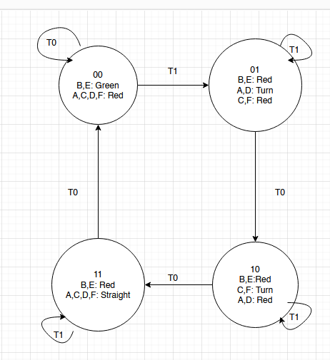 Based on estimated calculation, (B) and (E) red lights should last for about 30s based on the rate of cars. Which means S1, S2, S3 should last for 30s total, or 10s each. S0 can also last for 30s.

|  |  |  |  |  |  |  |  |
| --- | --- | --- | --- | --- | --- | --- | --- |
|  | Current State | Input | Next State |  |  |  |  |
|  | q1q0 | T | Nq1Nq0 |  |  |  |  |
|  | 00 | 0 | 00 |  |  |  |  |
|  | 00 | 1 | 01 |  |  |  |  |
|  | 01 | 0 | 10 |  |  |  |  |
|  | 01 | 1 | 01 |  |  |  |  |
|  | 10 | 0 | 11 |  |  |  |  |
|  | 10 | 1 | 10 |  |  |  |  |
|  | 11 | 0 | 00 |  |  |  |  |
|  | 11 | 1 | 11 |  |  |  |  |
|  |  |  |  |  |  |  |  |
|  | k-map | I | |  |  | I | |
|  | Nq1 | 0 | 1 |  | Nq0 | 0 | 1 |
| q1q0 | 00 | 0 | 0 |  | 00 | 0 | 1 |
| 01 | 1 | 0 |  | 01 | 0 | 1 |
| 11 | 0 | 1 |  | 11 | 0 | 1 |
| 10 | 1 | 1 |  | 10 | 1 | 0 |
|  |  |  |  |  |  |  |  |
|  | Nq1 = | q1'q0I'+q1I+q1q0' |  |  |  |  |  |
|  |  |  |  |  |  |  |  |
|  | Nq0 = | q1q0'I'+q1'I+q0I |  |  |  |  |  |

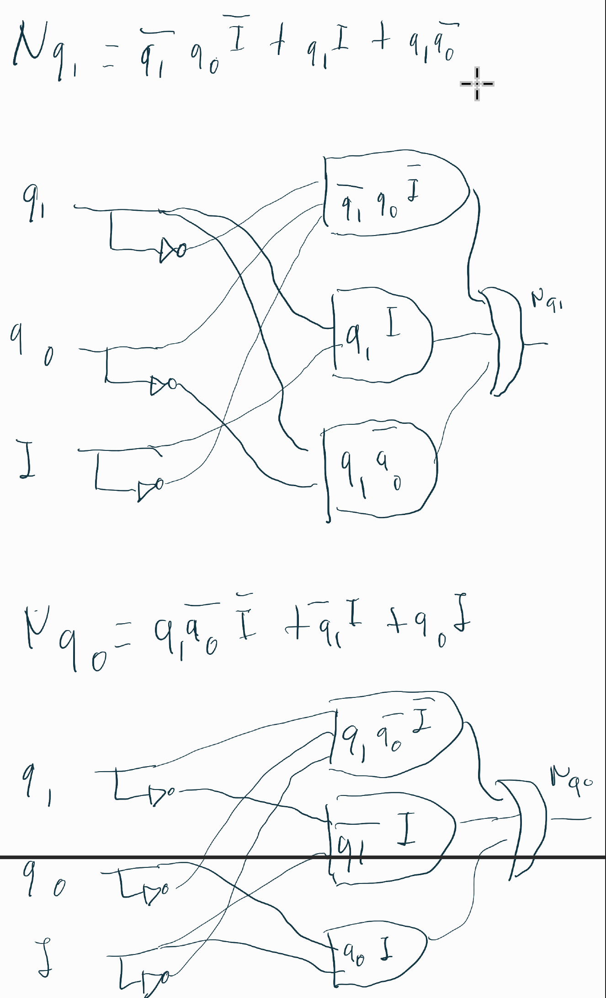

1. **Conclusions**

This lab asks to design a traffic light control system by using Finite State Machine to maximize traffic flow and minimize congestion. From the FSM, a Karnaugh map can be created, therefore also create logic circuits easily. This is an example to represent the real-world application of FSM, to help simplify the process of creating logic circuit system.